尚未把ODEs部分整理进来。缺少物理模型的一些结果。

In the modeling part, we are mainly working on simulating the function of the fermentation system at different levels and serving suggestions for future implementation.

We first introduce the pathway of our project.

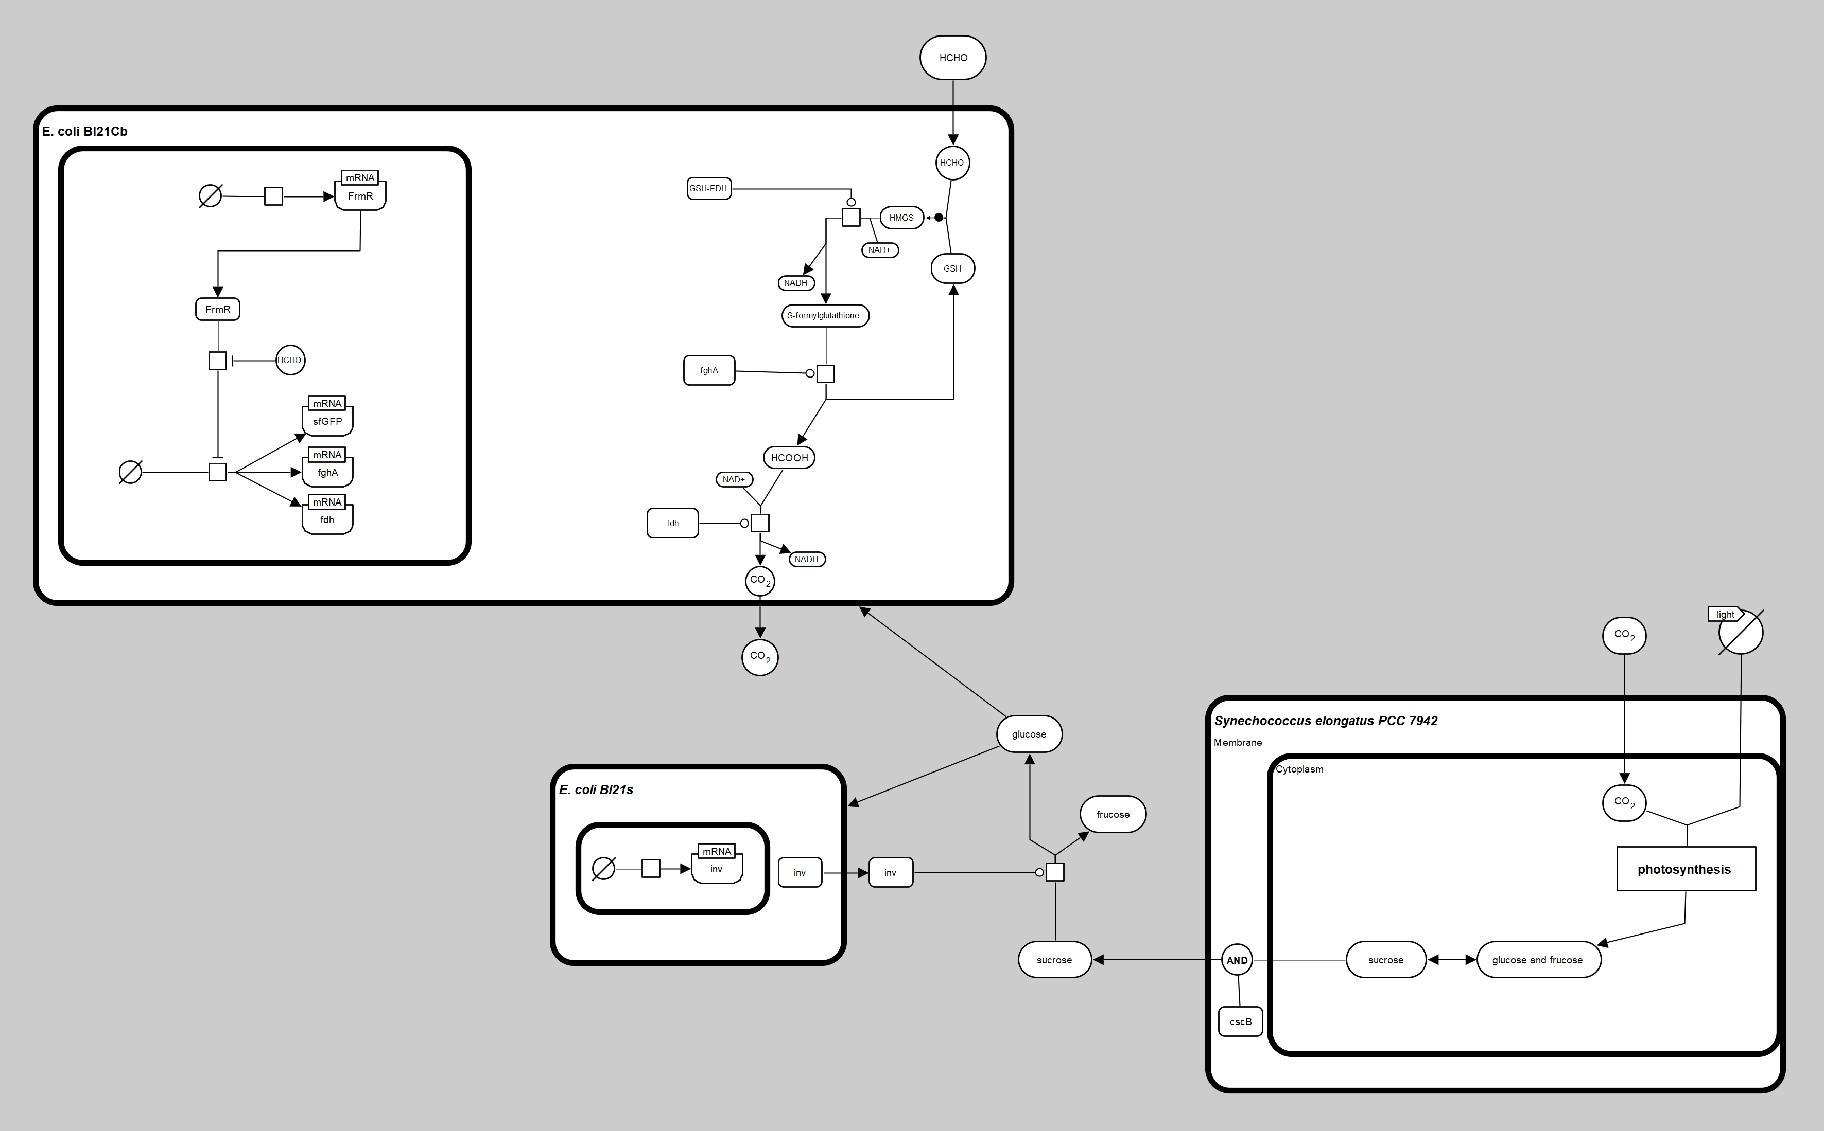

Figure The biochemical pathway of the project. *Escherichia coli Bl21* and *Synechococcus PCC 7942* are two selected engineering microorganisms. *E. coli Bl21Cb* is responsible for the degradation of formaldehyde, *Synechococcus PCC 7942* for sucrose production, and E. coli Bl21s for extracellular sucrose hydrolysis for both *E. coli* to digest. The figure follows the SBGN standard (Novère et al., 2009).

The work consists of two parts, flux balance analysis (FBA) and diffusion model of alginate beads considering bacterial metabolism, specifically, the photosynthesis of *Synechococcus PCC 7942,* the formaldehyde degradation function, and sucrose hydrolysis by two types of *E. coli*.

1. ODE system
2. Flux Balance Analysis (FBA)

The first part is about flux balance analysis, an approach for studying a genome-scale metabolic network, containing almost all known metabolic reactions, genes, and related enzymes for an organism (Orth, 2010). The reason we chose this approach as the simulation part is not only because of the constructed published microorganism models, but also through dynamic FBA and some well-developed toolboxes such as COBRA (Heirendt et al., 2019) and COMETs (Dukovski et al., 2021), we can track the changes in metabolite concentrations in the presence of complex reactions within microbial bodies, and even simulate the co-cultivation of blue algae and e. coli.

* 1. Verification

First of all, we need to verify the model. We searched for the existing E. coli Bl21 growth experiment data (Christensen & Eriksen, 2002) to compare with the chosen model iB21_1374 (Monk et al., 2013). We adjusted the intake limitation of glucose intake of the model to restrict it from unlimited nutrient intake, and the simulation result is presented below.

Table 1. Specific rates of growth and yield coefficients for growth of *E. coli* BL21 on glucose as carbon substrate.

| **Parameters** | **Reference value**  (Christensen & Eriksen, 2002) | **Simulation value** |
| --- | --- | --- |
| $μ$ ($h^{-1}$) | 0.38 $±$ 0.03 | 0.3796 |
| $$Y_{x/glc}({gg}^{-1})$$ | 0.41 $±$ 0.01 | 0.5109 |
| $$Y_{NH_{4}/x}({mmolg}^{-1})$$ | 9.6 $±$ 0.8 | 11.22 |

$μ$ ($h^{-1}$), specific growth rates estimated from gram in dry weight, $Y_{x/glc}({gg}^{-1})$, yield of biomass per unit of glucose consumed.

The equation selected to fit the growth curve is

$$\begin{aligned}m=e^{μt}+m_{0}\#\left( AUTONUM \backslash * Arabic \right)\end{aligned}$$

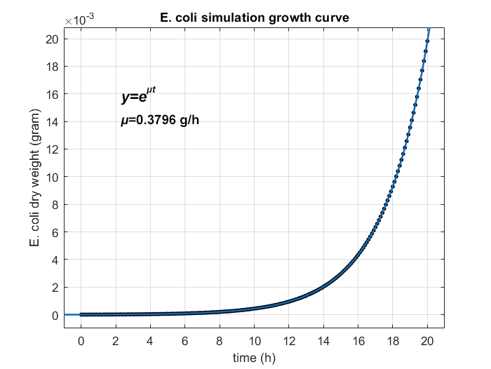

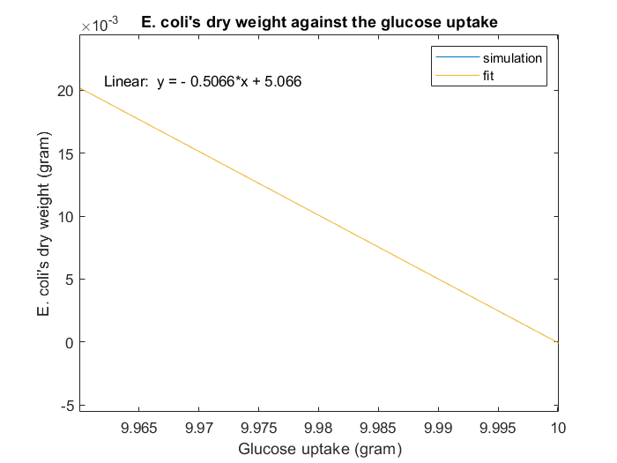

Figure Fitted curve of E.coli’s dry weight against glucose uptake.

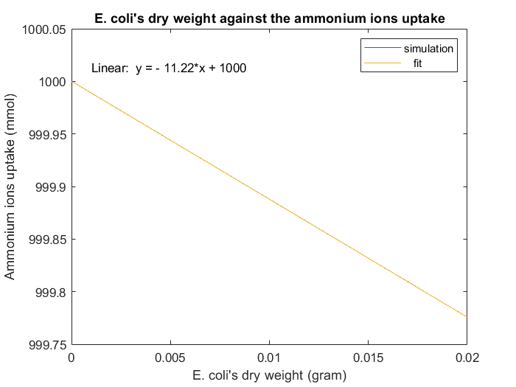

Figure Fitted curve of E.coli’s dry weight against NH4+ uptake. The total volume is set to sufficiently high.

Notice that the blue line for the simulation result is covered by the fit line.

Although the result is not perfectly consistent with the reference value, the bias is acceptable and predictable, for the real case has many more hidden variables, such as temperature and thermodynamic process.

* 1. Modification

Then, we modify the model according to the metabolite pathway, including adding sucrose transportation reaction on the algae model, extracellular sucrose hydrolysis reaction, and formaldehyde degradation pathway on two separate *E. coli* models.

* 1. Dynamic-FBA

After that, we adjusted the parameters to fit the experiment data, and the simulation result of *E. coli*’s HCHO consumption is presented below.

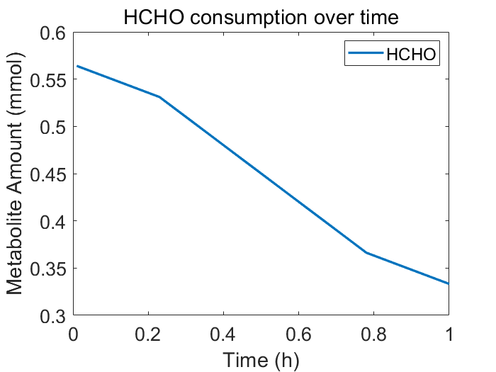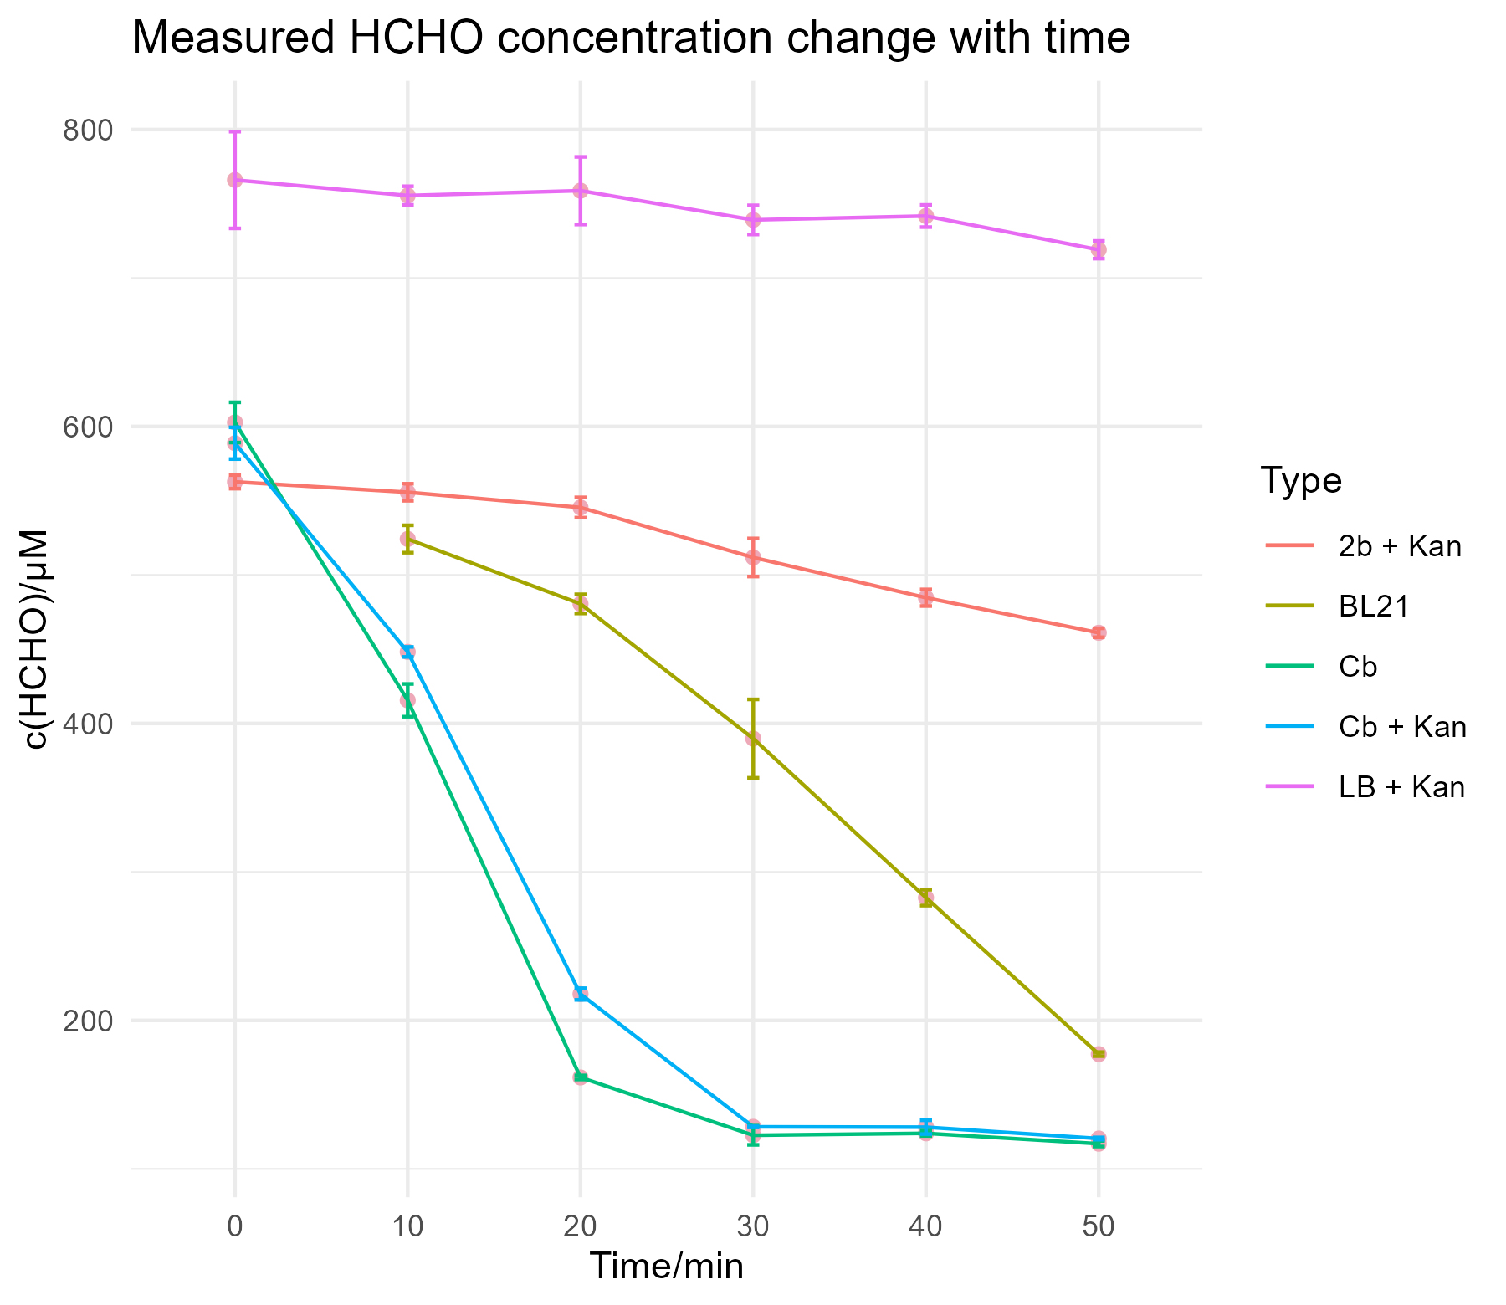

The experiment result of bl21 matches the simulation well.

~~After the verification, we were curious about how nutrient uptake affects formaldehyde degradation efficiency, so we did a robustness analysis between glucose uptake and formaldehyde uptake speed.~~

* 1. Ratio of coculture system’s components

We were curious about how to set the ratio between algae and *E. coli* so that the system would function stably.

To do that, we first analyzed the maximum production rate of algae.

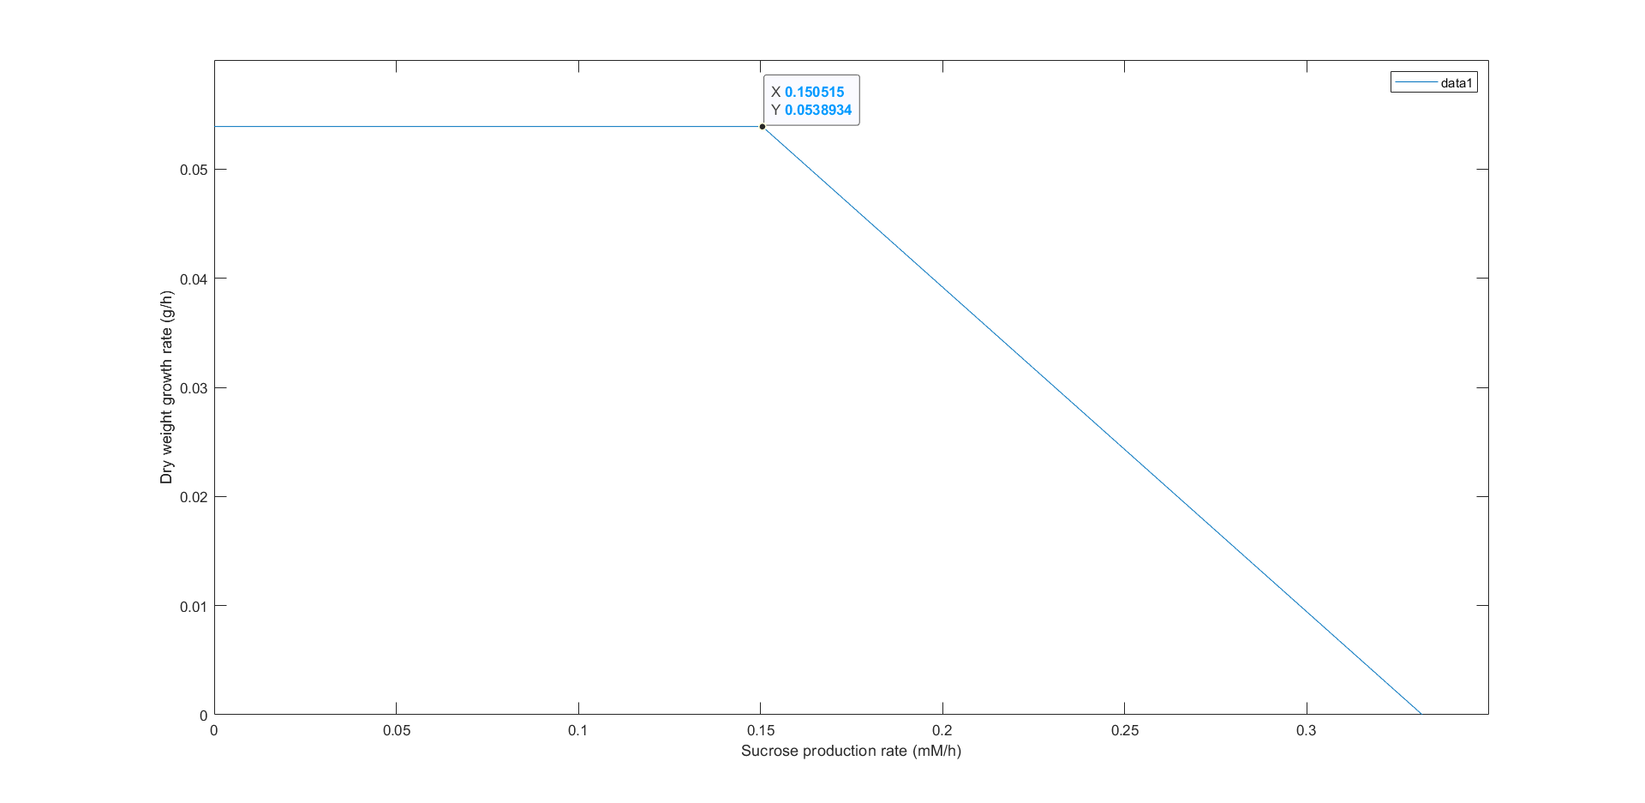

Figure Dry weight growth rate against sucrose production rate *in silico*, through robust analysis between biomass function and sucrose secretion reaction on GEM of *Synechococcus PCC 7942.*

The maximum sucrose production rate in unit biomass is 0.15 mM/h without a decrease in growth rate. We take this as the chosen value, assuming the cell always tries to maximize its growth rate.

Then we set up an optimization model to find the optimal ratio, based on a few assumptions.

1. They are both at exponential growth stage
2. All sucrose is hydrolyzed as soon as secreted.
3. Do not distinguish the *E. coli* for sucrose hydrolysis and formaldehyde degradation.
4. Other hidden effects are negligible.

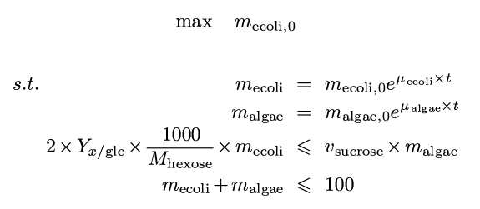

| **Parameters** | **Value** |
| --- | --- |
| $μ_{ecoli}$ ($h^{-1}$) | 0.38 |
| $μ_{algae}$ ($h^{-1}$) | 0.054 |
| $$Y_{x/glc}({gg}^{-1})$$ | 0.41 |
| $v_{sucrose}$ ($mmol{ h}^{-1}$) | 0.15 |
| $M_{hexose}$ ($g mol^{-1}$) | 180.16 |

We used Python to solve the model, and the optimized result is

$$m_{algae}:m_{ecoli}≈96.76:3.17≈30$$

We were excited to find that the result is similar to a coculture’s growth data collected from research by Hays et al. (2017).

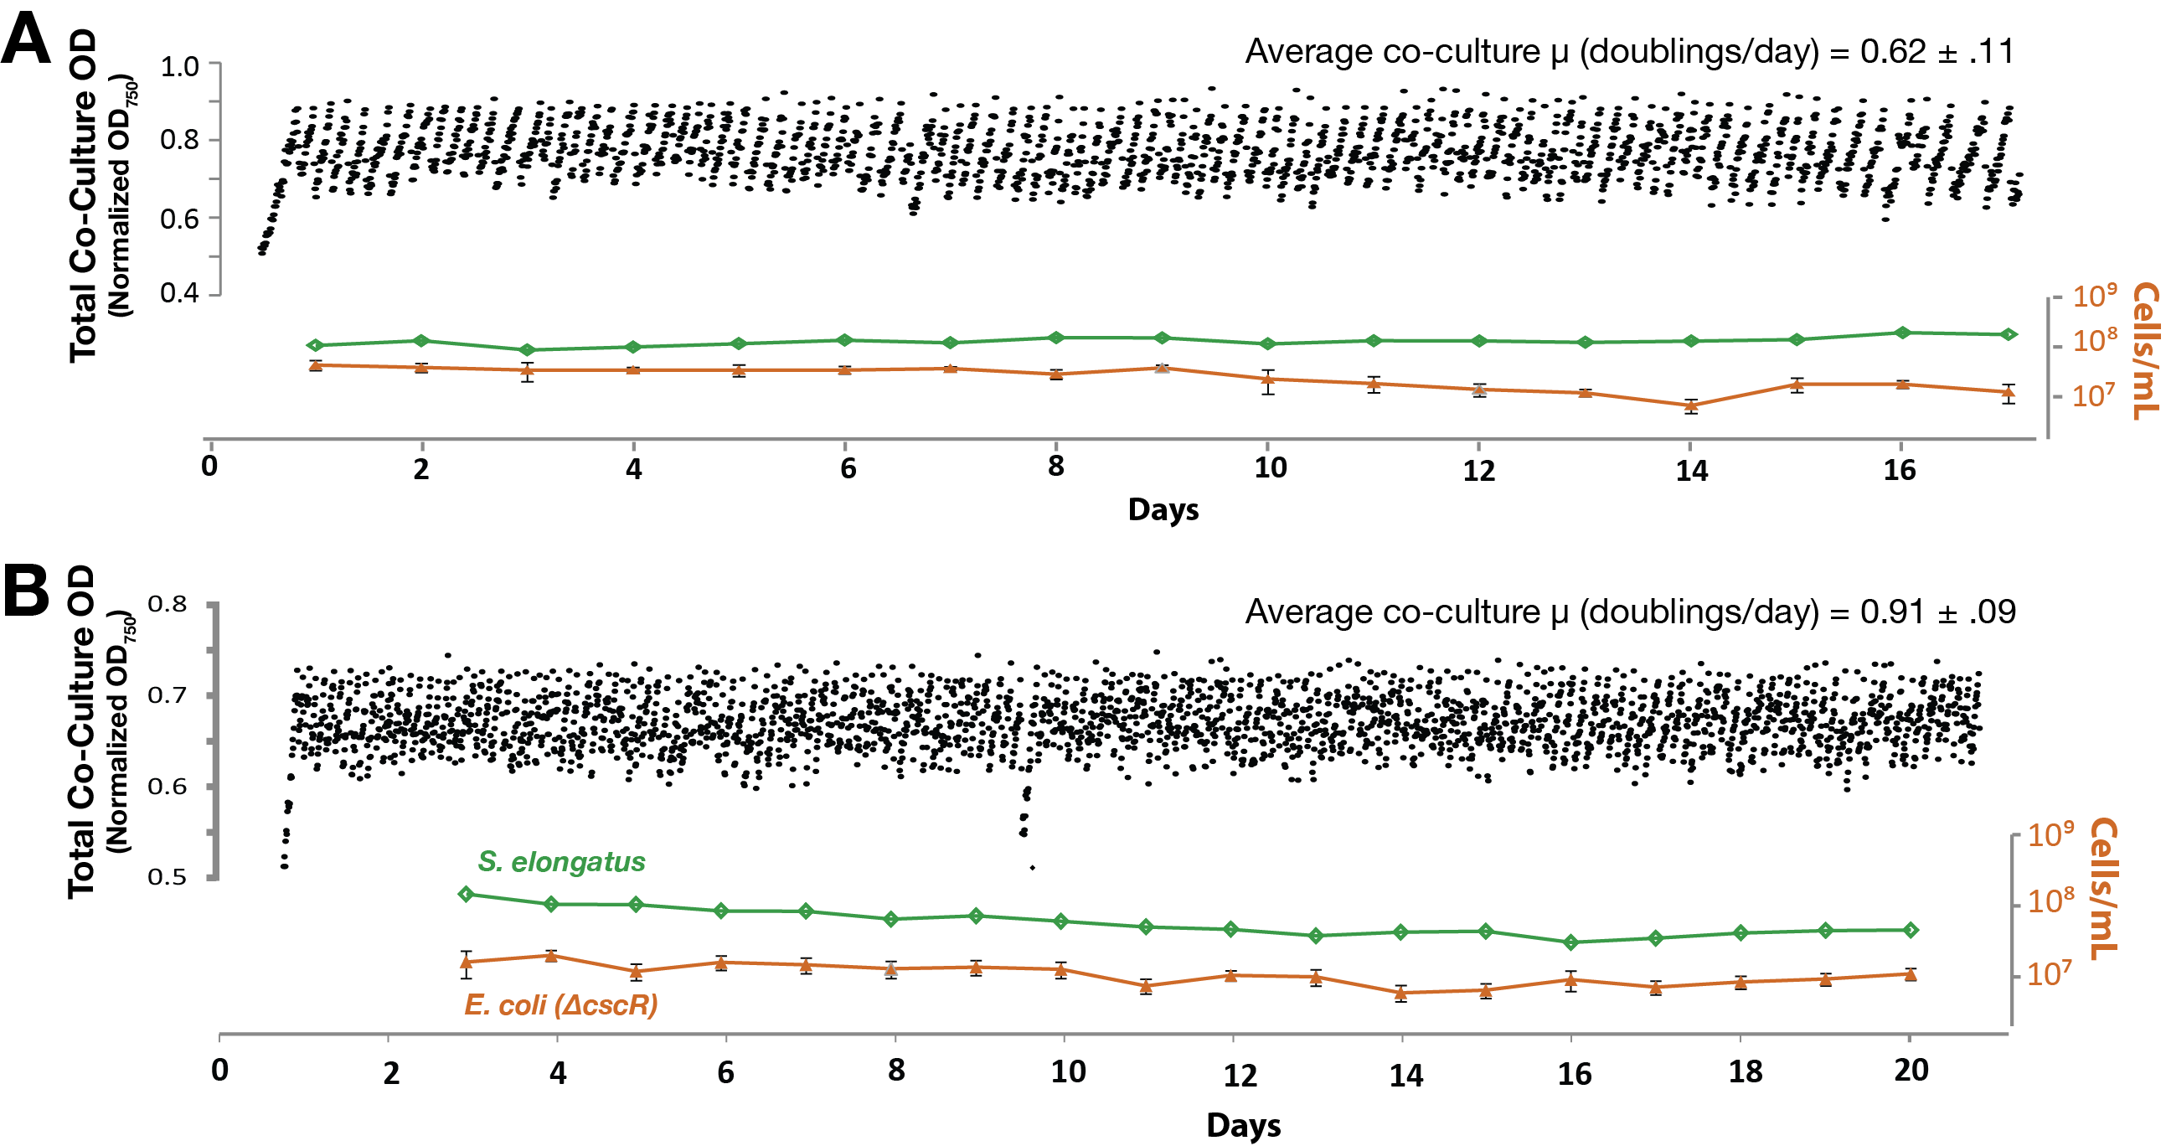

Figure Photobioreactor continuous co-culture replicates of *E. coli* W Δ*cscR* */cscB+* *S. elongatus* were set up in constant light. The optical density of the entire culture (black scatter plots) and cell counts for the individual species were tracked (green *S. elongatus,* orange *E. coli* W Δ*cscR*) for more than 2 weeks (Hays et al., 2017).

This provided a starting point for futural coculture experiments.

1. FEA

This part is aimed at giving an insight into how alginate beads affect the metabolite of the microorganism embedded. In our project, we designed three types of beads, one with blue algae for sucrose production, one with *E. coli* for sucrose degradation, and one with *E. coli* for formaldehyde degradation. During the development, we realized that we could increase the accuracy by the embedding ODE system, which describes the formaldehyde degradation pathway.

The model can be separated into two parts: diffusion and metabolite. We first developed the diffusion model and started a rough simulation, then combined the metabolite part with the diffusion model.

* 1. Metabolite function

Before we start, notice that one bead will only have one function, and we will not simulate multiple beads together for now.

* + 1. Formaldehyde detection

The detection is based on the FrmR operon regulation on GFP, and the outcome is that when formaldehyde is present, the beads will give green fluorescence under UV light.

Based on the research by Woolston et al. (2018), we chose Hill’s equation to fit the experiment data, and the result is presented below.

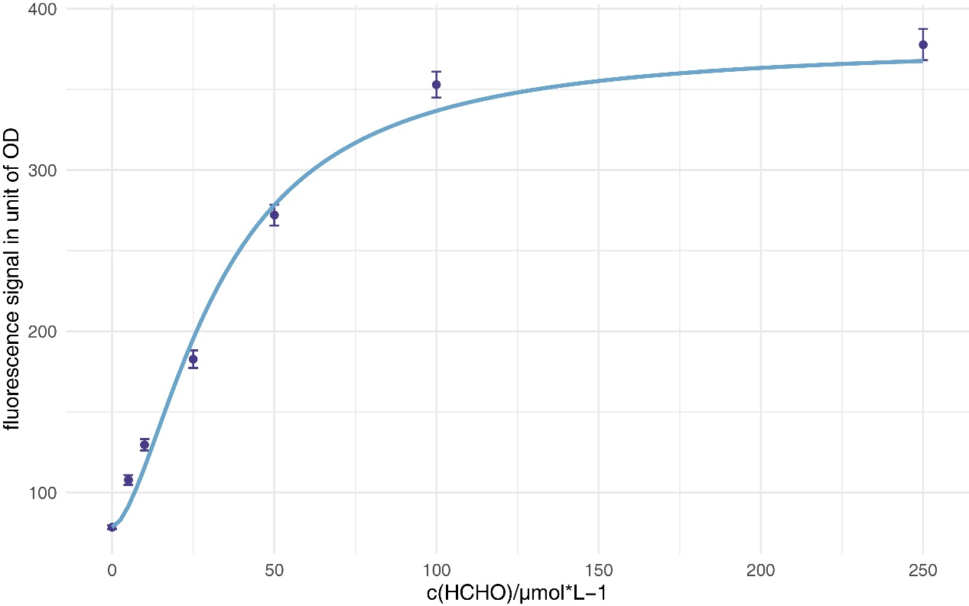

Figure Curve fitting with Hill’s equation.

Fitted equation:

$$\begin{aligned}S=S_{min}+\left(S_{max}-S_{min}\right)×\frac{{\left[F\right]}^{n}}{K_{m}^{n}+{\left[F\right]}^{n}}\#\left( AUTONUM \backslash * Arabic \right)\end{aligned}$$

Where S represents the fluorescence signal, and [F] represents the formaldehyde concentration. The result met our expectations.

| **Parameters** | **Estimate** | **Std. error** | **P** |
| --- | --- | --- | --- |
| $$K_{m}$$ | 32.7494 | 2.5972 | 5.57e-05 *** |
| $$n$$ | 1.6467 | 0.1996 | 4.27e-04 *** |

* + 1. Formaldehyde degradation

The reason we choose ODEs to build into the FEA is that this is the main part of the whole system.

* + 1. Photosynthesis

We describe photosynthesis with the Michaelis-Menten equation and obtain the parameters through curve fitting with data from the wet lab.

* + 1. Sucrose hydrolysis

This could be summarized as a Michaelis-Menten equation.

* 1. Diffusion model
     1. Model derivation

The diffusion model is based on Fick’s second law

$$\begin{aligned}\frac{∂c}{∂t}=\frac{∂^{2}c}{∂x^{2}}D\#\left( AUTONUM \backslash * Arabic \right)\end{aligned}$$

In three-dimension space, the formula can be rewrote with Laplacian operator

$$\begin{aligned}\frac{∂c}{∂t}=∇^{2}cD\#\left( AUTONUM \backslash * Arabic \right)\end{aligned}$$

Where $\begin{aligned}∇^{2}=\frac{∂^{2}}{∂x^{2}}+\frac{∂^{2}}{∂y^{2}}+\frac{∂^{2}}{∂z^{2}}\#\left( AUTONUM \backslash * Arabic \right)\end{aligned}$

Which means for a point, the change of concentration within unit time equals the point’s divergence times original concentration times the diffusion coefficient of the substance in a specific matter, in this case, the alginate is the matter.

The diffusion coefficient is related to the type of substance and the concentration of the medium, the values are given below, all at 0.2% of alginate.

| **Diffusion coefficient** | **Value($mm^{2}*s^{-1}$)** | **Reference** |
| --- | --- | --- |
| $$D_{glucose_water}​$$ | 6.7 | (McDonald, 1956) |
| $$D_{sucrose_water}​$$ | 5.2 | (Cussler, 1984) |
| $$D_{sucrose_gel}​$$ | 1.73 | (Pu & Yang, 1988) |
| $$D_{glucose_gel}​$$ | 2.23 | Manually, assume $$\frac{D_{glucose_{water}}​}{D_{sucrose_{water}}}=\frac{D_{glucose_{gel}}​}{D_{sucrose_{gel}}}$$ |
| $$D_{formaldehyde}$$ | 10.0 | Manually |

This formula tells us how a substance diffuses into another quantitively, and more importantly, based on former work, we could set up a simulation with the finite element method (FEM), which is suitable for solving partial differential equations and visualization.

* + 1. Finite Element Method (FEM)

We will briefly introduce how it works, to learn more details, please refer to some professional resources.

FEM is a numerical method to approximate the solution of continuous, boundary-initial-value problems described by partial differential equations as discrete models (Tekkaya & Soyarslan, 2014), which is commonly applied in practice in the engineering field.

Why did we choose FEM? Sometimes obtaining an analysis solution for the model is unnecessary, and we can tolerate the bias, then, instead of solving the model directly, we split the space into thousands even millions of nodes to discretization the space, and update the state of nodes from initial state step by step to discretization the time to simplify the problem.

With this idea, we develop the following simulation algorithm.

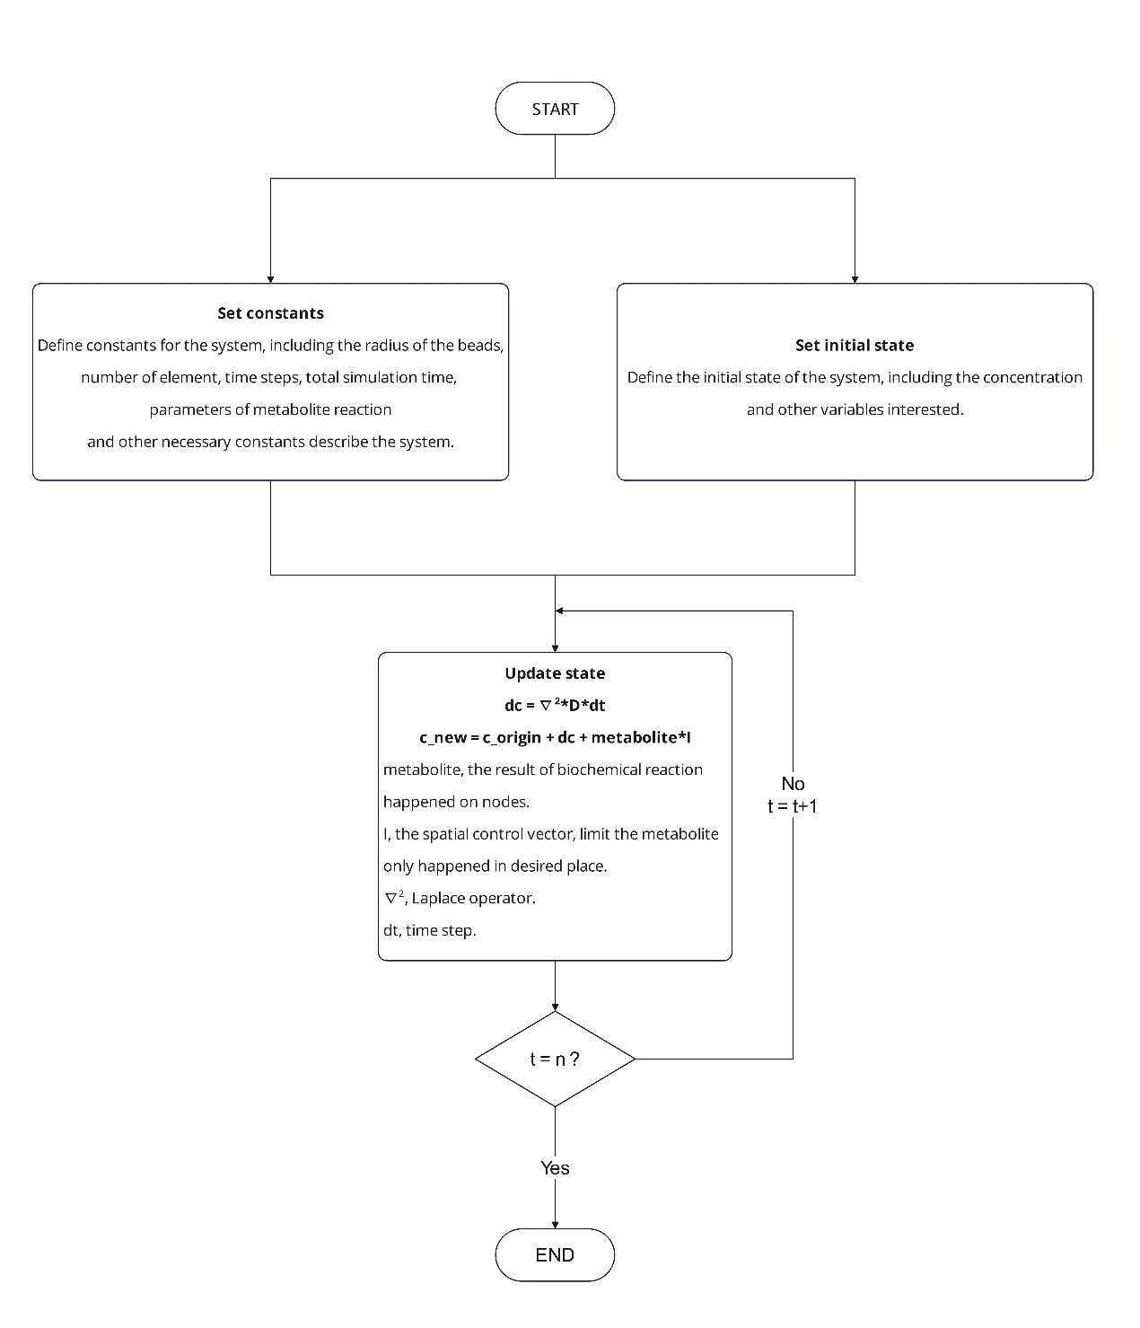

Figure The numeric simulation algorithm based on diffusion model and FEM.

With the simulation, we are able to get insight on how to build and improve the system and prevent some possible traps in advance.

* 1. Result

All plots are refreshed every 10ms simulation time.

* + 1. Simple beads

In this case, we do not care about the metabolite term and set it to zero.



Figure

When this result was obtained, it immediately came to our mind that, if the beads are static, the system's efficiency will be significantly affected due to the limit of substance’s diffusion near the beads.

To prove our thought, we refresh the outside concentration with 0 in each cycle to simulate the pump.



Figure

The result showed that at 300ms, the concentration at the center is lower than when not refreshed, which supports our previous thought and motivates the installation of a pump in our hardware.

* + 1. Consider sucrose hydrolysis

The metabolite term is based on the sucroase Michaelis-Menten equation.

* + 1. Consider formaldehyde detection

Now we focused on formaldehyde detection. We decided to simulate the response of the beads towards the decline of the environment formaldehyde concentration. The degradation rate is set as a constant

$$v=0.15μM/sec$$

obtained from the wet lab data when the formaldehyde degradation rate by *E. coli* is stable. The final result is shown below.

* + 1. Consider formaldehyde degradation

1. Discussion

We first set up the general biochemical pathway diagram with the help of wet lab members, which clarifies how the system works. Then, we start research and try to implement FBA to verify the system’s function.

When our team decided to build hardware, we started looking for a method to simulate the system and chose to simulate the beads. After that, we developed a model describing an “alginate bead with microorganism embedded”, and set up a mathematical simulation with the finite element method. The result served some insights into how diffusion affects the system, including the necessity of a pump, and the potential effect on cell distribution and growth.

There are still many things to be done in the future. The cell growth is limited due to the volume of the beads, and the distribution inside the beads is uneven. There are still bricks left aside, thus we upload our commented MATLAB code and, hopefully, it could present as a rough framework for teams that wants to give FEM a try.

“All models are wrong, but some are useful”, said George E. P. Box. We are glad that our work provided some meaningful results and understanding of the system function eventually.

Christensen, M. L., & Eriksen, N. T. (2002). Growth and proton exchange in recombinant Escherichia coli BL21. *Enzyme and Microbial Technology*, *31*(4), 566-574. <https://doi.org/https://doi.org/10.1016/S0141-0229(02)00153-9>

Cussler, E. L. (1984). Diffusion: Mass Transfer in Fluid Systems.

Dukovski, I., Bajić, D., Chacón, J. M., Quintin, M., Vila, J. C. C., Sulheim, S., Pacheco, A. R., Bernstein, D. B., Riehl, W. J., Korolev, K. S., Sanchez, A., Harcombe, W. R., & Segrè, D. (2021). A metabolic modeling platform for the computation of microbial ecosystems in time and space (COMETS). *Nature Protocols*, *16*(11), 5030-5082. <https://doi.org/10.1038/s41596-021-00593-3>

Hays, S. G., Yan, L. L. W., Silver, P. A., & Ducat, D. C. (2017). Synthetic photosynthetic consortia define interactions leading to robustness and photoproduction. *Journal of Biological Engineering*, *11*(1). <https://doi.org/10.1186/s13036-017-0048-5>

Heirendt, L., Arreckx, S., Pfau, T., Mendoza, S. N., Richelle, A., Heinken, A., Haraldsdóttir, H. S., Wachowiak, J., Keating, S. M., Vlasov, V., Magnusdóttir, S., Ng, C. Y., Preciat, G., Žagare, A., Chan, S. H. J., Aurich, M. K., Clancy, C. M., Modamio, J., Sauls, J. T., . . . Fleming, R. M. T. (2019). Creation and analysis of biochemical constraint-based models using the COBRA Toolbox v.3.0. *Nature Protocols*, *14*(3), 639-702. <https://doi.org/10.1038/s41596-018-0098-2>

McDonald, H. J. (1956). Electrochemistry in Biology and Medicine T. Shedlovsky (Ed.) New York, John Wiley &amp; Sons, Inc., 1955, 369 pp. *Clinical Chemistry*, *2*(1), 56-56. <https://doi.org/10.1093/clinchem/2.1.56>

Monk, J. M., Charusanti, P., Aziz, R. K., Lerman, J. A., Premyodhin, N., Orth, J. D., Feist, A. M., & Palsson, B. Ø. (2013). Genome-scale metabolic reconstructions of multiple <i>Escherichia coli</i> strains highlight strain-specific adaptations to nutritional environments. *Proceedings of the National Academy of Sciences*, *110*(50), 20338-20343. <https://doi.org/10.1073/pnas.1307797110>

Novère, N. L., Hucka, M., Mi, H., Moodie, S., Schreiber, F., Sorokin, A., Demir, E., Wegner, K., Aladjem, M. I., Wimalaratne, S. M., Bergman, F. T., Gauges, R., Ghazal, P., Kawaji, H., Li, L., Matsuoka, Y., Villéger, A., Boyd, S. E., Calzone, L., . . . Kitano, H. (2009). The Systems Biology Graphical Notation. *Nature Biotechnology*, *27*(8), 735-741. <https://doi.org/10.1038/nbt.1558>

Orth, J., Thiele, I. & Palsson, B. (2010). What is flux balance analysis? *Nat Biotechnol*, *28*, 245–248.

Pu, H. T., & Yang, R. Y. (1988). Diffusion of sucrose and yohimbine in calcium alginate gel beads with or without entrapped plant cells. *Biotechnol Bioeng*, *32*(7), 891-896. <https://doi.org/10.1002/bit.260320707>

Tekkaya, A. E., & Soyarslan, C. (2014). Finite Element Method. In (pp. 508-514). Springer Berlin Heidelberg. <https://doi.org/10.1007/978-3-642-20617-7_16699>

Woolston, B. M., Roth, T., Kohale, I., Liu, D. R., & Stephanopoulos, G. (2018). Development of a formaldehyde biosensor with application to synthetic methylotrophy. *Biotechnol Bioeng*, *115*(1), 206-215. <https://doi.org/10.1002/bit.26455>